Bridge Memorandum #10: Medical Emergency Assistance

This memo is to advise the fleet that TDI-Brooks International has a corporate medical membership with an international medical provider for emergency assistance that is available 24 hours a day every day. International SOS provides medical advice, service and assistance including primary, emergency and diagnostic services with facilities in over 70 countries and collect calls are accepted.
The membership ID is 11BMMS000226 and a list of available clinics and emergency centers, including phone numbers and email contacts, are listed in the ship web pages, Bridge page under “Contacts.” If you have Internet service, you can go directly into the ISOS web site and locate the alarm center nearest you at http://www.internationalsos.com/en/alarm-centers.htm .
If you have a medical emergency and are unsure how to proceed, don’t hesitate to call the contact numbers for advice. Below are the main contact numbers:
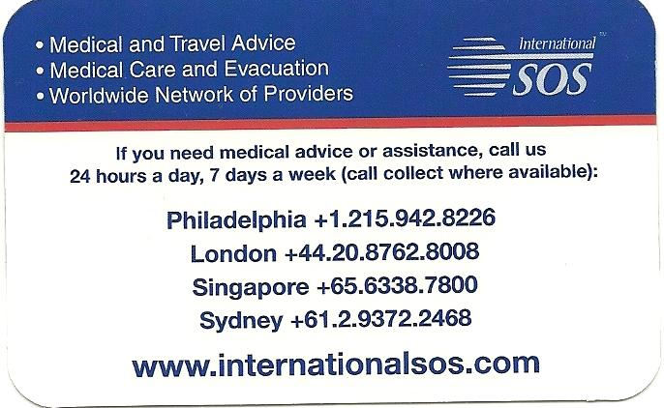
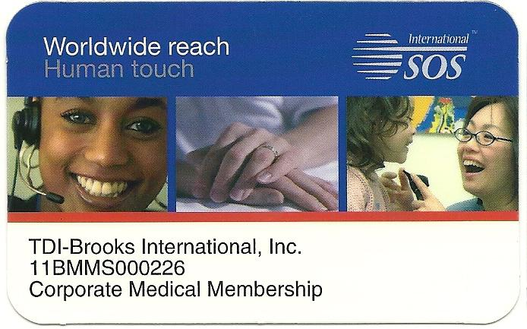
If a patient needs a medevac or transport to a medical facility, print and send with them a copy of this memo and a completed Patient Information Form, located on the ship web pages, SMM Forms Only page. Remember that any injury on a US flagged vessel requiring medical treatment beyond first aid also requires completing forms CG-2692 and CG-2962B for submittal to US Coast Guard. If the crewman is injured and unable to take the tests, complete the forms and state why the tests cannot be completed. Refer to SOP-GEN-007L for more details.

